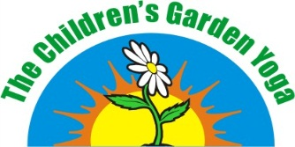
& Reiki
Adult Registration Form

Last Name |  |  | First Name |  | Adult Yoga |  |  | Adult Reiki
Home Phone | Work Phone |  |  | Mobile Phone | E-mail Address
Street |  |  |  | City |  | Prov | Postal Code
Alternate Contact |  | Alternate Contact Number

Health Concerns/Allergies/Other/What you hope to achieve from this class
Programme:
Start Date & Time #wks :
Cost: Cash Cheque

The Children's Garden is not responsible for any injury or illness that may be incurred while visiting or
participating in any of our programmes. It is always advisable to speak with your family physician before
undertaking any new physical fitness programme. Although this is a gentle stretch yoga programme, it
is important to follow your body’s inner wisdom and guidance and never move into a place of pain. Pain
does not benefit your body and may cause an injury. A nice stretch is not necessarily pain; please
discern between the two for ultimate well-being.

Signature Date

Please make all cheques payable to: Barbara Westgate
Mailing Address: 766 North Mile Road, London, ON N6H 2 X8
Email: natural_child@hotmail.com Phone: 519-474-3579

