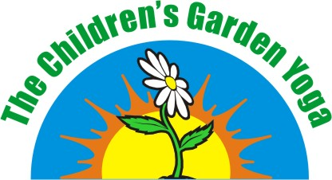
growing the whole child
Child Registration

Parent or Guardian's Last Name |  |  | Parent or Guardian's First Name
Parent or Guardian's Last Name |  |  | Parent or Guardian's First Name
Home Phone | Work Phone |  | Mobile Phone | E-mail Address
Street |  |  | City |  | Prov | Postal Code
Alternate Contact |  | Alternate Contact Number | Photo Release | Video Release
 |  |  | Photo/Video Notes:
CHILD'S INFORMATION
Child's Name | Birth Date DD MMM YYYY | Age | Children's Yoga | Children's Reiki
Child's Name | Birth Date DD MMM YYYY | Age | Children's Yoga | Children's Reiki
Child's Name | Birth Date DD MMM YYYY | Age | Children's Yoga | Children's Reiki
Health Concerns/Allergies/Other
Programme:
Start Date & Time
Cost: Cash Cheque
The Children's Garden is not responsible for an injury or illness that your child may incur while visiting or participating in any of our programmes.
SIGNATURE______________________________________________________DATE______________________________

Please make all cheques payable to: Barbara Westgate
Mailing Address: 766 North Mile Road, London, ON N6H 2X8
Email: natural_child@hotmail.com Phone: 519-474-3579

